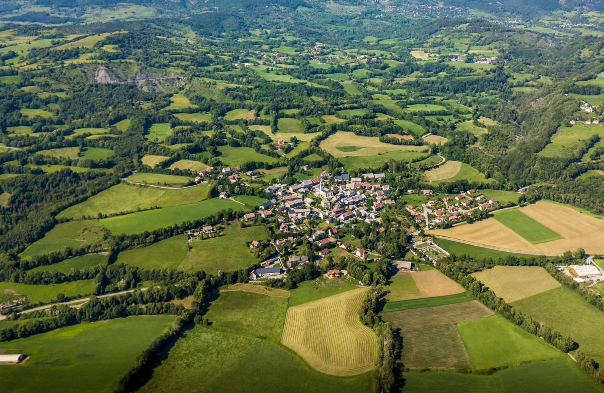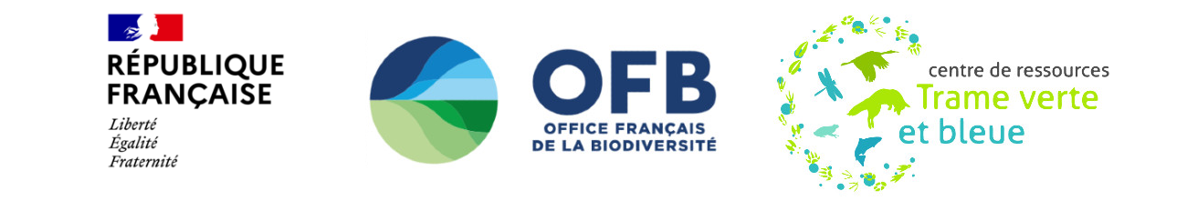



**>**

**How to assess ecological connectivity in mitigation hierarchy ?**

Method guide using

**Coordinators**: Jennifer AMSALLEM, Sylvie VANPEENE

**Authors**: Simon TARABON, Mathieu CHAILLOUX, Guillaume PAPET

Center

Provence-Alpes-Côte d'azur

# Foreword

Biodiversity is facing accelerated erosion and has become a global concern in recent decades. In the Anthropocene era, human activities are exerting constant pressure on natural resources and biodiversity, leading to the reduction and fragmentation of natural habitats, making it more difficult for animal species to move around. Stopping this phenomenon has become a growing concern in land-use planning. To halt this erosion, environmental policies have introduced new tools and regulatory obligations. This include in France i) the Avoid-Reduce-Offset sequence (legal version of mitigation hierarchy), reinforced by the 2016 Biodiversity Law aiming to protect species, natural habitats and ecological functions, and ii) the *Trame verte et Bleue* policy, which since the 2010s has aimed to network natural habitats.

Despite these tools and regulatory measures, the joint implementation of ecological continuity and mitigation hierarchy remains incomplete and insufficient to ensure that there is no net loss of biodiversity at any scale. This is due in particular to the lack of interest in ecological networks, but also to the absence of information and operational tools to meet the following objectives: how can ecological networks be identified? Which data can be used? What indicators should be used to assess the functioning of ecological continuities and the effects of different development scenarios?

In 2020, this observation is supported by a survey of professional practices carried out by INRAE for the French Biodiversity Office (OFB) within the Green and Blue Network Resource Center, as well as the doctoral thesis by S. Tarabon. In this context, additional work was carried out with a dual ambition:

* Target the most operational existing analysis methods and propose a relevant methodological framework to analyze ecological continuities for joint application with mitigation hierarchy;
* Develop a dedicated, accessible and free tool.

This document details the context leading to MitiConnect tool development and a guide to implement suggested analysis method with MitiConnect. This project is the result of many exchanges between the authors and a multi-disciplinary working group (WG) made up of experts from ecological continuity and mitigation hierarchy enviroments: government departments, regional environmental authority, academics, consultancies and project owners from the *Club Infrastructures Linéaires et Biodiversité* (CILB). This WG met 6 times between 2021 and 2023 to validate the proposed methodological choices and guarantee its operationality regarding profesionals' needs.

The main focus is on terrestrial and wetland environments. The guide is not suitable for rivers[1] and does not cover marine environments.

# Authors and contributors

## Authors

* Jennifer Amsallem (INRAE)
* Sylvie Vanpeene (INRAE)
* Simon Tarabon (Ubiquiste)
* Mathieu Chailloux (Geomatricks)
* Guillaume Papet (INRAE)

## Contributors

The authors would like to thank :

* Françoise Sarrazin (OFB),
* Thomas Schwab (Cerema),
* Laurent Bergès (INRAE),
* Françoise Burel (CNRS, MRAE),
* Marie Papadopoulos (CILB),
* Simon Trauet (MTECT DEB),

## Working Group members

* Fabien Quétier (Biotope),
* Coralie Calvet (CEFE),
* Fabien Paquier (OFB),
* Céline Clauzel (LADYSS),
* Eric Vindimian (CGEDD AE, MRAE),
* Alexandre Kavaj (MTECT-CILB),
* Francis Isselin (University of Tours),
* Sylvain Pioch (LAGAM, Université Paul Valéry Montpellier 3),
* Alexandre Cluchier (ECO-MED),
* Didier Soustelle (DREAL Occitanie),
* Brian Padilla (MNHN),
* Stéphanie Longa (PNR Vexin français),
* Agnès Mechin (ECO-MED),
* Annabelle Cluzeau (DMR/SAM4, DGITM)
* Jérémy Bachmann (DREAL Hauts-de-France),
* Mehdi Azdoud (Commissariat Général au Développement Durable),
* Bénédicte Lefevre (DREAL Hauts-de-France),
* Lucy Llinarès (DREAL Occitanie),
* Thierry Mougey (Fédération des PNR),
* Michel Perret (MTECT-DEB),
* Thomas Corbet (OFB),
* Robin Goffaux (FRB),
* Yannick Autret (SRI/SDR/MiBSAA, Commissariat Général au Développement Durable)),
* Michel Metais (CNPN),
* Lucile Tirello and Juliana Ienciu (Écotone)
* Vincent Guillemot (Dervenn).

# Contents

This guide is organized into three sections. The first part presents the issues and existing measures relating to ecological continuity and mitigation hierarchy, as well as their joint implementation. The second part presents the different methods to identify ecological continuities through modeling, and the methodological choices made in this guide. The third part introduces how to use MitiConnect in mitigation hierarchy.

-

Foreword 2

Authors and contributors 3

Introduction: why this guide? 3

1.1 Ecological continuity: challenges and existing systems 4

1.2. The Avoid-Reduce-Compensate sequence: issues and legal context 7

1.3. Articulating ecological continuity and the ERC sequence: a necessity to ensure no net loss of biodiversity... 9

1.4. ...but faced with many operational challenges 10

1.5. A methodological guide: for whom and what? 12

How to model ecological continuity? 14

2.1. Assessing ecological networks: existing approaches 15

2.2 Graphab, a tool adapted to the problem 17

Introduction to the QGis MitiConnect extension 20

3.1 General philosophy 21

3.2 Application examples 23

MitiConnect v1.0 User Manual 28

4.1. Prerequisites 29

4.2 User manual 29

Bibliography 30

# Part 1.

# Introduction: why this guide?

## 

## 1.1 Ecological connectivity: issues and existing systems

To face biodiversity loss, initiatives to take account of ecological networks have multiplied across Europe since the 2000s. Ecological networks are made up of biodiversity habitats in which species live and disperse, linked by ecological corridors (linear, surfacic or "Japanese steps"). Such network meet all the needs of animal and plant species, at different spatial scales, to ensure their survival (reproduction, feeding, search for new territories, etc.).

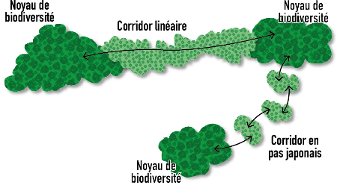

**Simplified diagram of ecological networks made up of biodiversity reservoirs (species habitats) and ecological corridors enabling the movement of individuals**. Taken from Tarabon, 2020.

Against this backdrop, the European and then French legal framework - following the Grenelle 1 (2009) and 2 (2010) laws - has evolved to institutionalize ecological networks in land-use planning, with the introduction of the *Trame verte et bleue* (Green and Blue Network) policy. Its objective is to take into account all environments that ensure the long-term conservation of species on a territory, and involves maintaining a coherent network of natural and semi-natural ecosystems.

 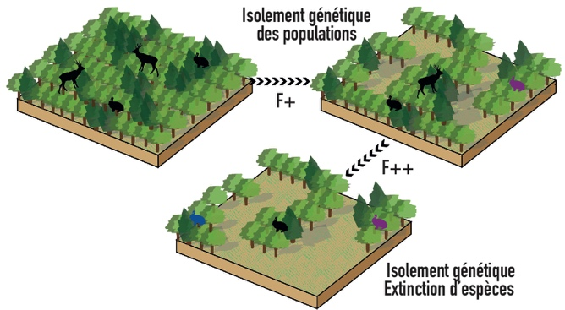

**Example of fragmentation (F) of natural environments induced by land use and its consequences on species populations**. ©J. Gaudreau (left) and taken from Tarabon, 2020 (right).

The Grenelle laws and their implementing decrees have introduced the need to protect or restore ecological connectivity into the Environment and Urban Planning Codes. Article L. 371-1 of the Environment Code states that ecological connectivity contributes to :

* Reduce the fragmentation and vulnerability of natural habitats and species habitats, and take account of their movement in the context of climate change,
* Identify, preserve and link important areas for biodiversity preservation through ecological corridors,
* Preserve wetlands,
* Take into account the biology of wild species,
* Ease genetic exchanges necessary wild flora and fauna survival,
* Improve landscapes quality and diversity.

Ecological connectivity must therefore be taken into account when drawing up :

* Schemes, plans and programs ruled by Green and Blue Network policy, which makes it possible to integrate biodiversity at various scales of a territory, from the regional scale of the SRADDET[2] to the local scale of urban planning documents.
* Development projects, which must be compatible with land-use planning regulations in force, or subject to specific regulations (impact studies, etc.).

Each territorial level is linked to the next by a legal relationship of enforceability:

* *Compatibility*, which implies an obligation not to contradict the fundamental orientations of the higher standard, leaving a certain amount of leeway to specify and develop the orientations of the documents;
* *Take into account*, which implies a slightly more flexible obligation of compatibility, with possible derogation on justified grounds.

SRADDETs must therefore take account of the national guidelines for biodiversity conservation. Urban planning documents must take account of the SRADDET's objective report and be compatible with its general rules. There is a principle of subsidiarity, whereby each level of approach to the Green and Blue Network has its own legitimacy and can take an interest in new issues more directly linked to the territory concerned, to the knowledge available (or yet to be acquired), and to the vision of local stakeholders.

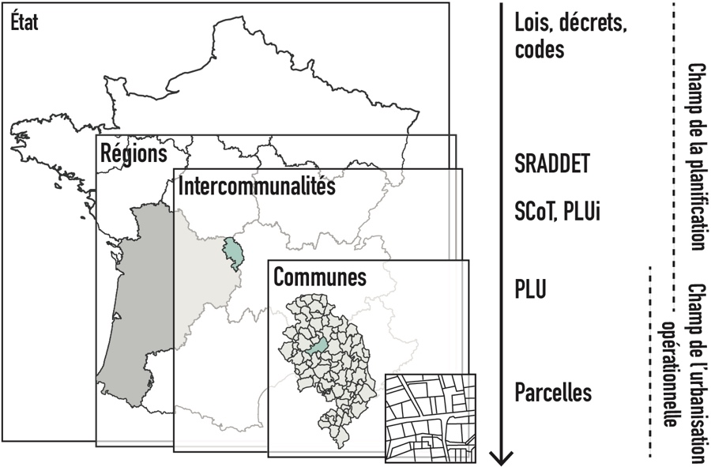

**Scales for taking ecological connectivity into account in planning and operational urbanization tools.** Taken from Tarabon (2020)

**Regulatory summary and degrees of enforceability for project developers, depending on the project and the developer's status with regard to ecological connectivity and mitigation hierarchy**.

|  |  |  |  |
| --- | --- | --- | --- |
| **Tools** | **Obligation TVB origin** | **Level of enforceability** | **Opposable to** |
| National TVB guidelines (ONTVB) | Art. L 371-2 of the French Environment Code | Compatibility | - Planning documents  - National projects |
| SRADDET | SRADDET instituted by Art. L 4251-1 et seq. of the Code général des collectivités territoriales (CGCT).  Contents defined in Art. R 4251-1 and R 4251-6 of the CGCT.  In particular, they must include "the objectives of protecting and restoring biodiversity, based on the identification of areas forming the TVB defined in L. 371-1 of the Environment Code and specified in Art. R 371-19 du CE".  It must take into account the ONTVB. | The SRADDET includes :  - An objectives report illustrated by a summary map,  - A booklet containing general rules (and in particular rules for restoring, maintaining or improving the functionality of environments necessary for ecological connectivity),  - Appendices.  The rule is binding. The other documents are indicative (non-binding). | -SCoT (must be compatible with the general rules of the SRADDET booklet provided for in [art. L 4251-3 of the](https://www.legifrance.gouv.fr/affichCodeArticle.do?cidTexte=LEGITEXT000006070633&idArticle=LEGIARTI000006392325&dateTexte=&categorieLien=cid) CGCT for those of their provisions to which these rules apply, and in the Ile-de-France region with the  SRCE provided for in [article L. 371-3 of the French Environment Code](https://www.legifrance.gouv.fr/affichCodeArticle.do?cidTexte=LEGITEXT000006074220&idArticle=LEGIARTI000042017243&dateTexte=&categorieLien=id))  - Projects sponsored by the French government and public-sector contractors |
| SRCE | L371-1 to 3 of the Environment Code  (only for the IdF region, otherwise the SRADDET takes its place). It must take into account the ONTVB. | Compatibility | - SCoT in Ile-de-France,  - Directly enforceable against work carried out by the State and public MOs in Ile-de-France. |
| SCoT | Art. L. L122-1 to L122-19; then L. 141-1 et seq. of the French Urban Planning Code and L. 131-1 et seq. In particular, it defines "the methods for protecting the areas necessary for maintaining biodiversity and preserving or restoring ecological connectivity and water resources. To this end, it may identify preferential areas for renaturation, through the transformation of artificial land into non-artificialized land" (3rd paragraph of art. L.141-10 du CU). | Compatibility (L. 131-1 to L 131-6 of the French Planning Code) | Lower-level planning documents (PLU, PLUi, Cartes communales). |
| PLUi/PLU | Art. L. 101-2, [L. 151-1 to L. 154-4](https://www.legifrance.gouv.fr/codes/section_lc/LEGITEXT000006074075/LEGISCTA000031211143/" \l "LEGISCTA000031211925) and [R. 151-1 to R. 153-22](https://www.legifrance.gouv.fr/codes/section_lc/LEGITEXT000006074075/LEGISCTA000031719975/" \l "LEGISCTA000031720663) of the French Planning Code, L131-1 et seq. | Compliance | Works, constructions, landscaping, planting, scouring or raising the ground, as well as, where applicable, the opening of classified installations belonging to the categories covered by the PLU/PLUi. |
| TVB strategy for Regional Nature Parks (PNR) | Article R333-3 of the CE: the NRP charter includes "the guidelines for protection, enhancement and development envisaged for the duration of the classification and, in particular, the fundamental principles for protecting landscape structures in the territory of the NRP and the objectives for preserving and restoring ecological connectivity".  Must take into account SRADDET or SRCE or Schéma d'aménagement régional. | Compatibility | SCoT |
| TVB strategy (département, Plan National d'A ction en faveur des espèces protégées, métropoles, communes, etc.). | There is no regulatory definition of these strategies, which remain a matter of political will on the part of the communities mentioned. | Consistency with the provisions of the SRADDET, SRCE or regional development plan, which often specify how the stated objectives are to be implemented. | Not applicable |
| Impact studies  (regardless of the original procedure: IOTA, ICPE, land clearing) | Art R. 122-5 of the CE | All impact studies must examine the project's impact on biodiversity, which must include ecological connectivity. | Project subject of impact study |
| Environmental assessment | L122-1 of the French Environment Code |  |  |

## 1.2. Mitigation hierarchy: issues and legal context

Mitigation hierarchy is the technical and operational expression of France's commitments to preserve biodiversity. It aims to stop biodiversity loss against a backdrop of habitat destruction and fragmentation by making it a positive issue for decision-makers, controlling anthropogenic pressures on species, natural environments and their functions, and improving the effectiveness of biodiversity preservation policies (Biodiversity Plan 2018, then National Biodiversity Strategy 2023).

Its aim is to design, build and operate development projects that do not result in any loss of biodiversity, and even generate gains. It encourages project developers to implement three types of measures in a hierarchical manner:

* Avoidance measures by modifying the project in order to eliminate a direct or indirect negative impact that the project would generate;
* Mitigation measures to reduce as far as possible the duration, intensity and/or extent of the impacts of the project that could not be avoided;
* Offset measures to offset any significant direct or indirect residual effects of the project that could not be avoided or reduced.

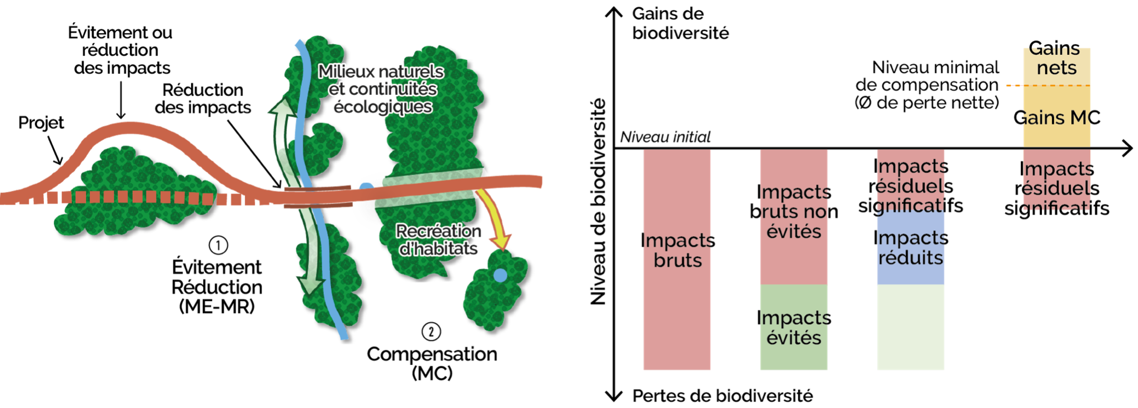

**Principle of avoidance (ME), reduction (MR) and offset (MC) measures in the ecological equivalence assessment**. Adapted from Tarabon, 2020.

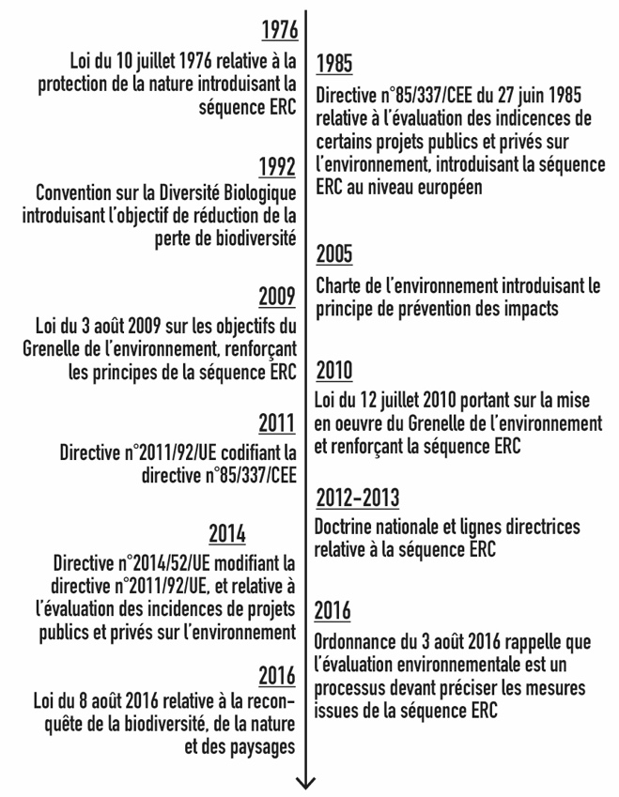Mitigation hierarchy has been governed by European law since Council Directive 85/337/EEC of June 27, 1985 on assessing public and private projects effects on the environment. It has been enshrined in French law of July 10, 1976 on nature protection. Long lacking in application, it has been regularly consolidated for systematic implementation, from the reform of impact studies in 2010 to, more recently, the law for the reconquest of biodiversity, nature and landscapes in 2016 (known as the "Biodiversity" law).

**Main regulatory changes related to the Avoid-Reduce-Offset sequence**. Taken and modified from Tarabon, 2020.

Mitigation hierarchy is based on respect for the general principles enshrined in Article L. 110-1 of the French Environment Code, in which numerous points have been clarified as regulations have progressed. These include :

* Implement a sequenced approach to avoidance, reduction and offset,
* Take into account the different types of impact (direct, indirect, induced and cumulative, whether temporary or permanent),
* Achieve equivalence between the losses caused by the project and the ecological gains brought about by the offset measures (sizing approach specified in the recently published ecological offsetting sizing guide, CGDD, 2021),
* Ensuring ecological or administrative additionality, in order to generate an ecological gain that would not have been achieved in its absence,
* Locate offsetting measures in functional proximity to impacts,
* Take into account the timing of measures in relation to impacts, so as to avoid intermediate impacts,
* Ensure the sustainability of measures for as long as impacts persist,
* Monitor and control measures, and adapt them if initial targets are not met,
* Include all stakeholders in decision-making processes.

Find out more:

* OFB resource center for the implementation of mitigation hierarchy: https://erc-biodiversite.ofb.fr
* Guide to implement the standardized approach of ecological offsetting sizing : <https://www.ecologie.gouv.fr/sites/default/files/Approche_standardisée_dimensionnement_compensation_écologique.pdf>

## 1.3. Linking ecological connectivity and mitigation hierarchy: a necessity to ensure no net loss of biodiversity...

Maintaining and/or restoring ecological connectivity is a prerequisite to preserve the viability of populations on medium and large scales. The analysis of ecological networks using a multi-scalar approach thus appears to be a major lever for a better understanding and, consequently, preservation of biodiversity, as demonstrated by the "Green and Blue Network" system.

Nevertheless, mitigation hierarchy is still mainly focused on a project-centric scale without really assessing ecological functionalities at different spatial scales. Development projects, whatever their scale, continue to generate irremediable effects on biodiversity and their functioning, making it impossible to halt the loss of biodiversity (MTES, 2019).

The link between ecological connectivity and mitigation hierarchy is becoming strictly necessary, in particular to meet certain objectives of the 2030 national biodiversity strategy to reduce the pressures on biodiversity.

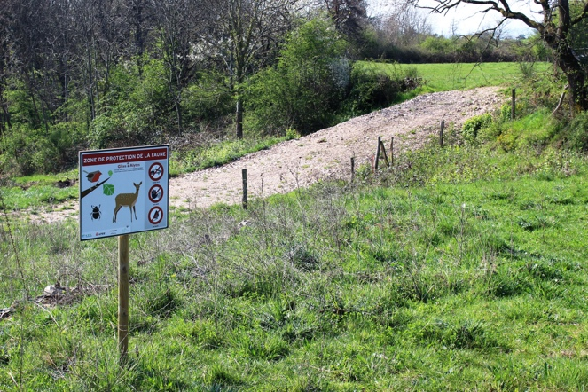 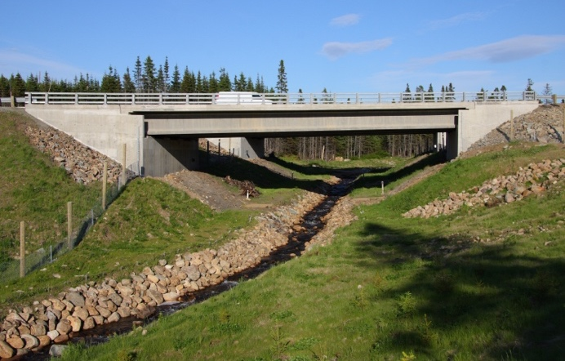

**Avoidance and reduction measures for biodiversity and ecological connectivity .** ©SA Cephas / Acer Campestre

## 1.4. ...but faced with many operational challenges

#### 1.4.1. Heterogeneous and/or unfamiliar assessment methods for profesionals

Many studies deal with the functional aspects of biodiversity only on the basis of empirical approaches reduced to a simplified assessment (classification of issues from low to high) without any real demonstration. Ecological connectivity is therefore insufficiently taken into account in studies, for lack of means to quantify it. This applies equally to project effects at avoidance stage and at offsetting stage, where little effort is made to ensure the accessibility of chosen sites chosen to impacted species and that the gains are commensurate with the impacts. Field expertise or expert analysis of structural connectivity alone can do little to understand the processes involved at medium and large scales in complex situations.

This observation, supported by the literature and the survey of mitigation hierarchy stakeholders conducted by INRAE in 2020 (unpublished), can be explained by several phenomena. First of all, no method for demonstrating ecological equivalence applied to ecological connectivity has been imposed in France. The environmental authority does not have a prescriptive role and is often undemanding in this area (with the exception of certain regions), which does not encourage the application of uniform assessment methods. However, in recent years, a number of scientific articles, theses, study reports (CEREMA, 2017) and research programs (notably within the framework of ITTECOP[3] or ANR)[4] have examined the application of mitigation hierarchy in France. Despite the requirements of European and French regulations, stakeholders are generally unanimous in their observation that this approach is insufficiently applied. Against this backdrop, several methodological frameworks have been developed in France (see, for example, recent theses by Bezombes, 2017; Bigard, 2018; Tarabon, 2020) to improve application of the mitigation hierarchy by integrating, to a greater or lesser extent, the functional component of biodiversity.

Despite the development of so-called "operational" methods by the scientific community, there is a significant gap between researchers and operational stakeholders, making it difficult to achieve the stated objective of operationality. This may be due to a lack of tools and/or methods known to operational actors, justifying their high expectations in the development of tools adapted to operational uses and constraints (2020 survey, INRAE, unpublished). These expectations have been increasing, following the various debates on offsetting, but also the 2016 Biodiversity Law which reinforced the objectives of conserving biodiversity and its dynamics.

Despite the research and documents published in recent years, there is little documentation available for operational stakeholders to quickly learn about emerging methods, or tools to facilitate decision-making processes in projects with tight schedules.

### 1.4.2. Little anticipation of mitigation hierarchy at local scale

Linkage between ecological connectivity and mitigation hierarchy should be a factor in achieving the objectives of no net loss of biodiversity on a local scale. Nevertheless, *Ollivier et al* (2020) have shown that mitigation hierarchy is still not very territorialized, since only 14 local initiatives (currently being developed or implemented, carried out on territories ranging from several hundred hectares to the size of a region), were identified during the 2018 survey of researchers, government departments and developers.

Moving from a "project-by-project" application to an anticipated, planned and territorialized organization of mitigation hierarchy is a real challenge to ensure that ecological connectivity is preserved right from the plans and programs stage, and can be integrated into land-use and urban development tools (cf. for example Bigard, 2018). The approach must therefore be thought through globally, with the same goals as at local projects scale. This ambition means taking into account all of a territory's development projects, not just those subject to environmental assessment[5] , to offer greater spatial coherence in the preservation of biodiversity components.

In addition, a territorialized strategy for mitigation hierarchy ensures a planned and mutualized spatial organization of measures, especially by sizing and locating offsets in relation to all land development projects. However, given the scientific and technical complexity of the subject, and the insufficiency of the knowledge and resources already mentioned, environmental assessments leave little room for understanding how ecological networks work.

Our aim is therefore to offer a forward-looking tool suitable for all project phases and scales, from planning to operations, whether as part of a regulatory approach or on a voluntary basis. The specific frameworks applied to the different scales are described in sections 1.1 and 1.2 of this chapter.

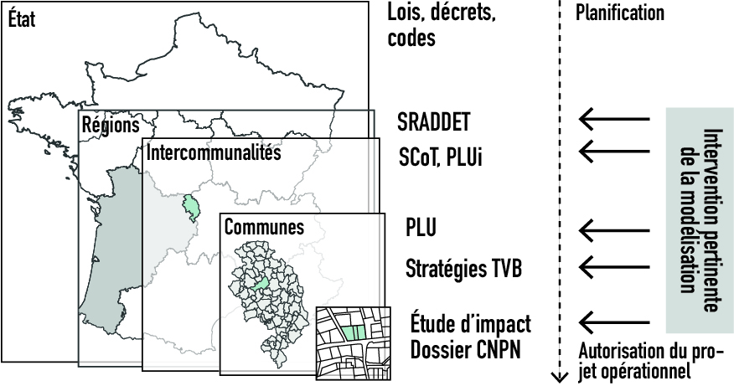

**Scales and planning processes in which the use of modeling is relevant to jointly study ecological continuities and the ERC sequence.** Taken from Tarabon, 2020.

## 

## 1.5. A methodological guide: for whom and what?

### 1.5.1. Target audience

Today, main stakeholders involved in taking ecological connectivity into account when assessing projects are those who accompany project owners and carry out environmental studies: engineering consultants. But audience can be extended to other protagonists: associations, natural areas managers and technical departments of local authorities, who are sometimes involved, depending on their human and technical resources, in the overall assessment of biodiversity issues.

This does not apply directly to investigating authorities, environmental authorities or public institutions, whose role is to support and monitor the implementation of mitigation hierarchy. However, they do need to understand the issues at stake, the method principles and the main results derived from the tool, in order to be able to have a critical look at how ecological functionalities are taken into account in studies.

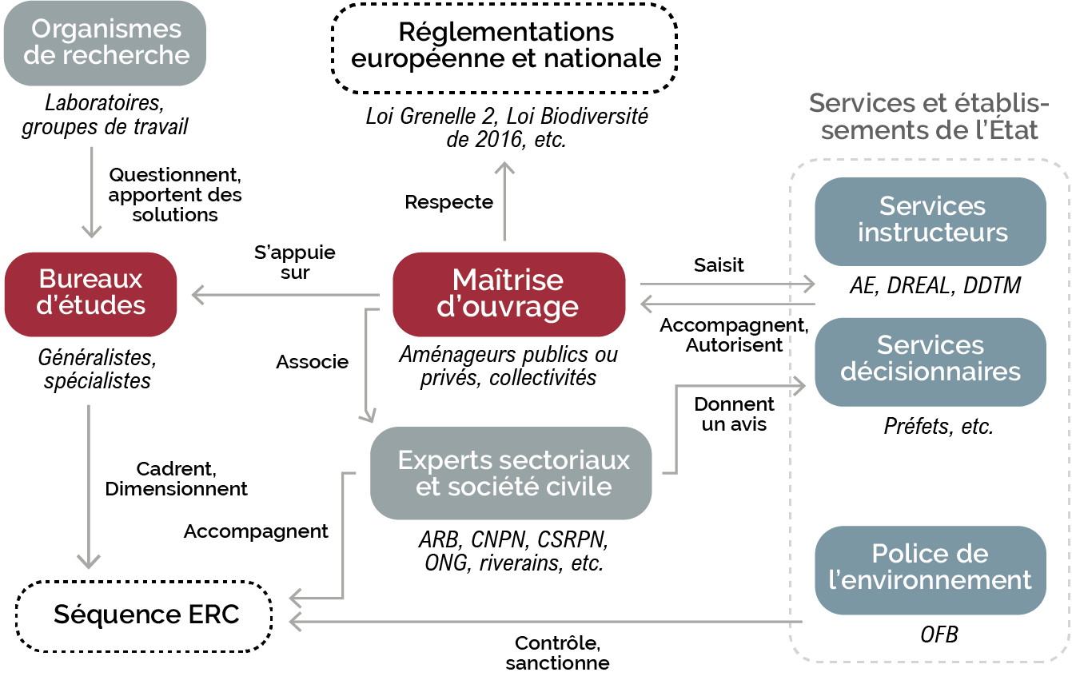**Actors involved in the decision-making and operational processes of the ERC sequence. Practitioners concerned by the use of a specific tool to integrate ecological continuities into the system appear in red.** Modified from Tarabon, 2020.

### 1.5.2. Guide objectives

Considering introductory elements, this document will :

* Take stock of existing methods and target those that are most operational or adapted to the issues at stake;
* Provide a methodological framework to assess and spatialize ecological connectivity issues at the scale of an operational or territorial project;
* Address the issue of quantifying impacts and assessing ecological equivalence in terms of connectivity by proposing one or more suitable metrics;
* Propose a modelling framework for the various stages of mitigation hierarchy (from preliminary considerations to the search for offsetting sites);
* Help the user in data preparation and model parameterization.

### **Part 2** .

# How to model ecological network ?

## 

## 2.1. Assessing ecological networks: existing approaches

Field inventories are generally not sufficient to understand the ecological processes involved at medium or large scales in complex situations.

Realized" connectivity can be a means of identifying ecological networks by targeting areas where moving individuals have been observed in the field. It can be assessed using GPS tracking or capture-mark-recapture data (*Calabrese and Fagan, 2004*). These models are useful for estimating the movement capacities of species (distance, habitat preference, etc.), but are difficult to use for estimating i) habitat connectivity, due to the lack of exhaustive results and the resources required to acquire the data, and ii) the response of connectivity to changes in land use or occupation, in the context of prospective approaches. In this context, understanding the functioning of ecological networks through modeling is an appropriate solution that takes on its full meaning.

The representation and evaluation of habitat networks takes advantage of the seminal article by Urban and Keitt (2001), which proposes a spatially explicit representation of the metapopulation graph, in which populations are represented by the nodes of a graph and exchanges between these populations by the edges. Landscape graphs are thus simple spatial graphs whose nodes commonly correspond to the habitat tasks of the species under consideration, and links to potential dispersal paths between these nodes. They have opened up new perspectives for understanding, in particular, the conditions for preserving movement between habitat patches, and have been a catalyst for work on ecological connectivity. Graph theory provides an analytical framework for measuring network indicators from an operational perspective (Urban *et al.*, 2009).

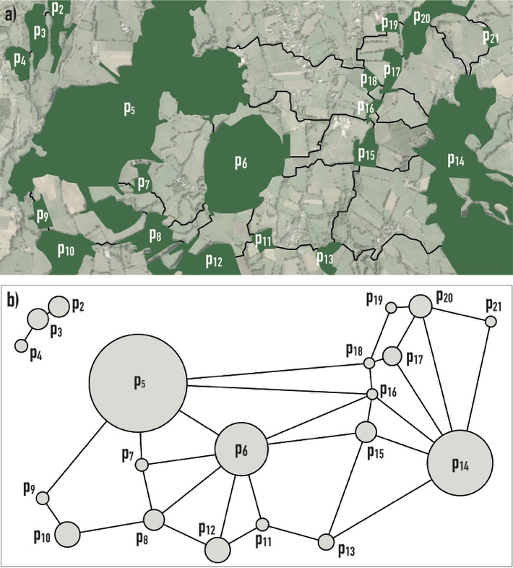

**Realistic (a) and topological (b) representation of landscape graphs, made up of habitats (nodes) and least-cost paths (links).** Taken from Tarabon (2020)

Currently, the main methods used to identify and evaluate ecological networks are derived from landscape graphs. The models differ in terms of the complexity of the ecological processes considered, the modeling assumptions and their need for prior knowledge. Padilla *et al* (2022) recall the characteristics of models linked to different levels of complexity:

* Structural models (level 1) rely exclusively on landscape configuration to estimate connectivity. The indices used relate, for example, to the surface area of habitats, their shapes, their qualities and the distances separating them.
* Static models (level 2) associate landscape elements with a value representing the biotic interaction capacities of species. They can be used to study mobility (point dispersals, seasonal migrations, daily movements) based on indications of the carrying capacity of environments and species dispersal.
* Dynamic models (level 3) additionally incorporate one or more temporal components, taking into account the evolution of landscapes and/or populations over time. These models can be used, for example, to study both species mobility and the effects of environmental modification (periodic climatic changes, global warming, land-use planning).
* Stochastic models (level 4) incorporate a degree of randomness into the estimated ecological processes. Stochasticity can play a part in reproduction, survival and certain movements, as well as in the landscape with extreme climatic events.
* Models of interspecific interactions (level 5) explicitly integrate several co-dependent species (predation, competition, etc.). These models are still in their infancy, as current multi-species approaches consist of modeling each species separately and compiling the results a posteriori.

The following figure shows the evolution of technical complexity (data acquisition, number of parameters, data volume, calculation time, etc.) as a function of the ecological complexity of the processes modeled. At each level of ecological complexity (from 1 to 5), the models integrate the parameters of the lower levels.

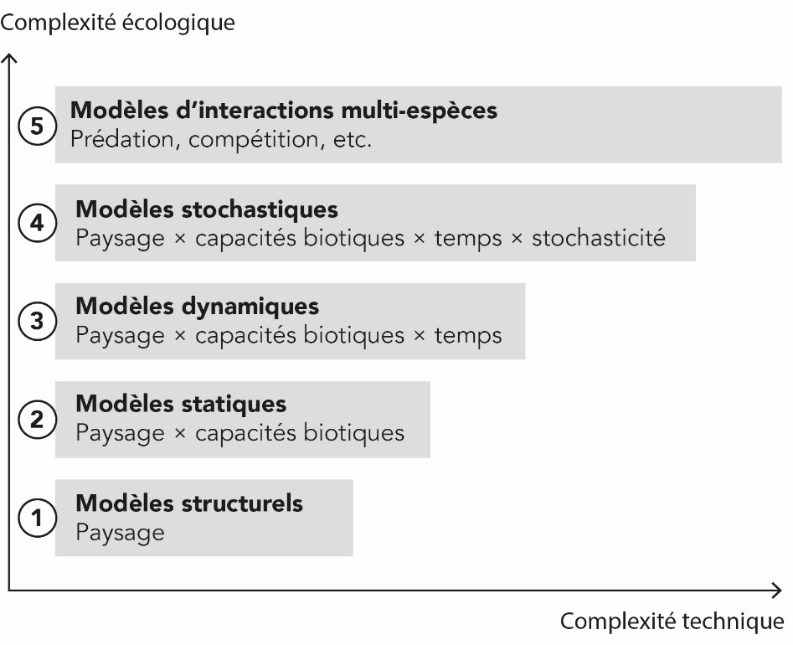

**Evolution of technical complexity as a function of the ecological complexity of the processes modeled.** Adapted from Padilla *et al.* (2022).

Several tools are now available for identifying ecological networks and their functioning. For structural connectivity, modeling can be based on the "dilation-erosion" method (Vogt *et al*., 2007) enabled by GIS software (QGis or ArcGis). However, ecological processes are rarely explored, as this approach does not take into account the dispersal capacities and behavior of species or the different environments they cross.

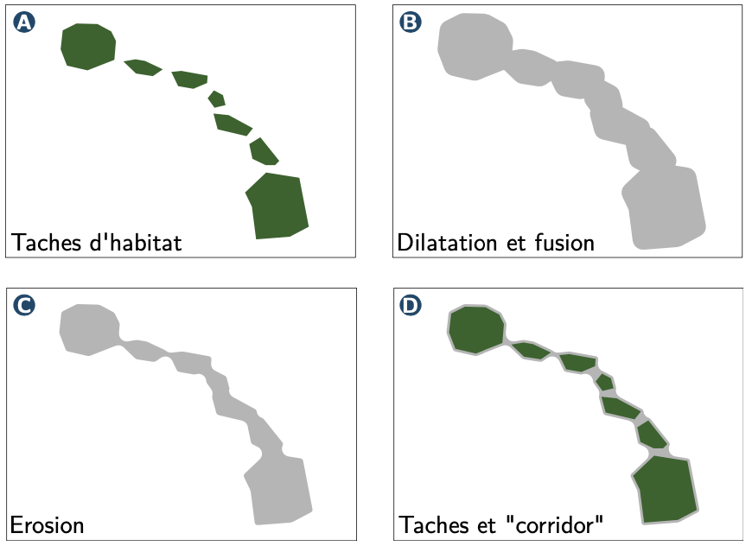

**Structural connectivity modelling based on the dilation-erosion method representing the areas potentially crossed by individuals between two habitat patches by traveling a minimum distance.** Taken from Savary, 2021.

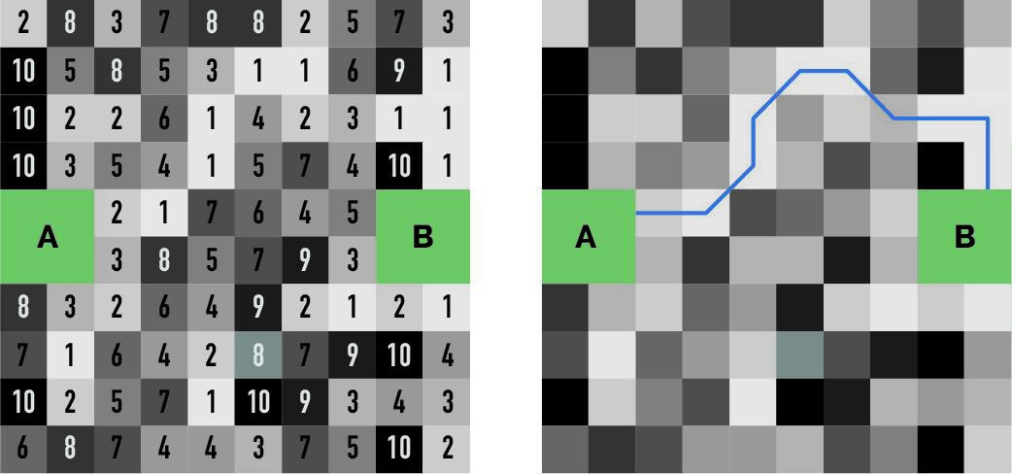Tools for analyzing the functional connectivity of species habitats are more numerous and depend on the levels of ecological complexity detailed above. All these tools consider the resistance that each landscape element exerts on the mobility of species, in order to understand the behavior of species in the landscape. The landscape matrix is thus represented by a resistance surface in which a "cost" is associated with each pixel (whose size depends on the resolution considered) according to the type of land-use category it represents. Graph links are calculated from least-cost paths (Adriaensen *et al.*, 2003), which identify areas that minimize movement costs.)

**Example a) of converting the landscape matrix into cost units (from 1 the most favorable, to 10 the most constraining) and b) identifying a path of least cost between the two habitats A and B.** Modified from Rudnick *et al.* (2012).

The existing tools for assessing functional connectivity and their main characteristics are summarized in the following table.

## 2.2 Graphab, the right tool for the right job

The challenge of this project lies above all in the development of a proven operational tool, accessible to a large number of players and adapted to different contexts of use (Méchin, 2020). Design offices need to adapt to the requirements of instructing departments, but the tool must above all match the human and technical resources of the various practitioners, even if this means losing ecological complexity.

**Summary and comparison of existing modeling tools for assessing ecological continuity**

|  |  |  |  |  |
| --- | --- | --- | --- | --- |
| **Tools** | **Features** | **Accessibility** | **Viewing results** | **Evaluation of individual flows** |
| BioDispersal (Chailloux & Amsallem, 2018)  Package R gdistance (van Etten, 2017) | They illustrate the most functional areas without taking into account the carrying capacity of habitats (proportional to their surface area, quality or productivity), on the assumption that animals move optimally with knowledge of the landscape environment. | Open source | Media permeability gradient | No |
| Linkage Mapper (McRae & Kavanagh, 2011)  CircuitScape (McRae & Kavanagh, 2011) | Use circuit theory, based on the rules applied to electrical circuits, linking the flow of people to the flow of electrons in a circuit. Circuits are networks of nodes (corresponding to habitat tasks) connected to each other by resistors, and support specific metric calculations. | Open source | Current (CF) and several other metrics | Yes |
| Graphab (Foltête *et al*., 2021)  Conefor Sensinode (Saura & Torne, 2012) | Tools specifically developed around landscape graphs, their representation and analysis. These tools have gained in popularity with the availability of geographic data and the computing capacity required for their development, but also thanks to the development of free software. | Open source | Different connectivity metrics | Yes |
| MetaConnect / SimOïko (Moulherat *et al*., 2020) | Simulates the behavior of species during their existence as a series of sequential movement decisions. These models can produce realistic results if the input data is reliable, but they are very demanding in terms of information about the species and their ecology. | Software not accessible | Intensity of individual flows | Yes |

As presented above, Graphab[6] (Foltête *et al*., 2021) and Conefor Sensinode (Saura & Torne, 2009) are two tools specifically developed around landscape graphs, their representation and analysis. These tools have gained in popularity with their accessibility (open source tool), the availability of geographic data, computing capabilities and the relevance of the results produced. It was decided to use Graphab as the basis for the development of a specific QGis extension.

The work of Bergès *et al* (2020) and Tarabon (2020) recently demonstrated the tool's relevance in the context of the ERC sequence. These authors have proposed several similar methodological frameworks for linear transport infrastructure projects, development programs and land-use planning. However, these studies have highlighted difficulties in implementing and/or reproducing these approaches, due in particular to :

* More or less complex and time-consuming preparation of input data (land-use map, model parameters, etc.),
* The preparation and interweaving of data linked to each development scenario, as well as the interpretation and exploitation of results (maps, graphs, etc.). There is as much data to prepare and results to explore as there are scenarios, depending on both the hypotheses to be tested (for each stage of the ERC sequence) and the number of species mobilized.

This observation once again supports the idea of developing an adapted, accessible and easy-to-use plugin. The ambition of this guide is to fully address the issue of joint implementation of the TVB and the ERC sequence, based on the basic functionalities provided by Graphab and new features.

Graphab, which is now available as a java GUI and a QGis extension (Graphab for Qgis), is under constant development by the ThéMa laboratory (Foltête *et al*., 2021). This facilitates development and joint work with all research teams on this software.

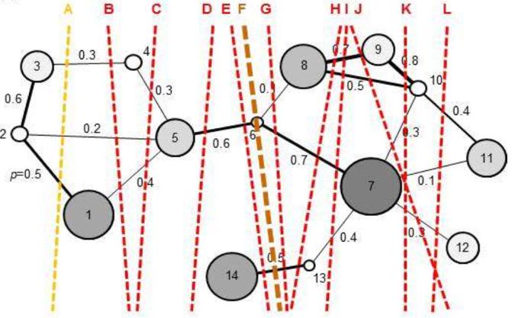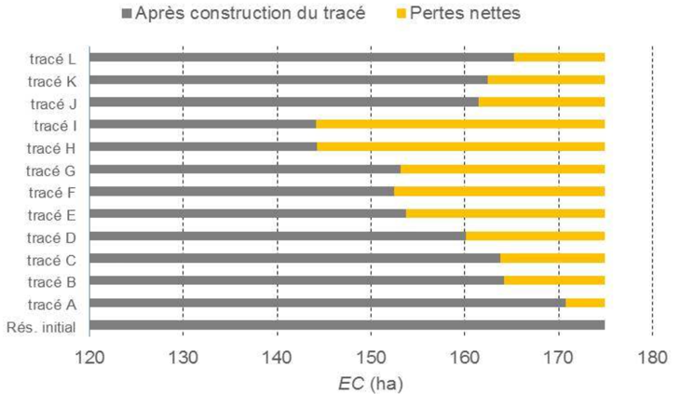

**Comparison of 12 geographical variants of linear transport infrastructures using the global *EC* metric.** Taken from Bergès *et al*. (2019).

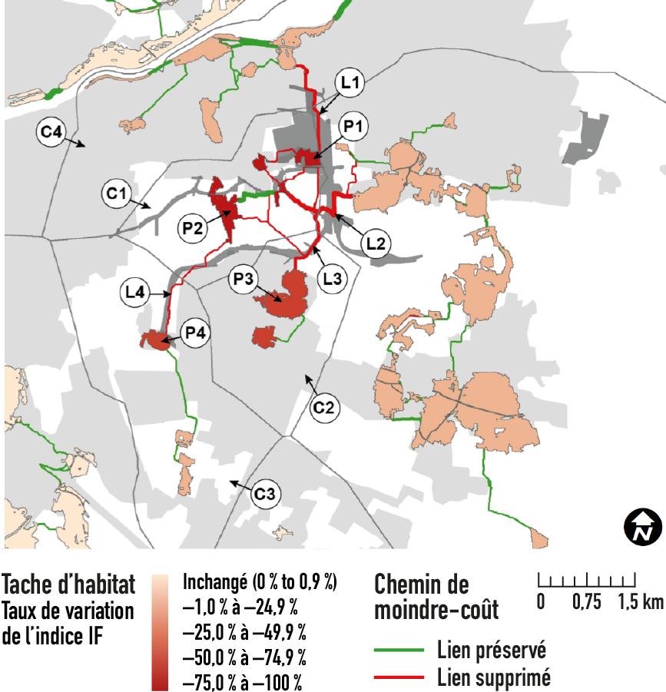*-*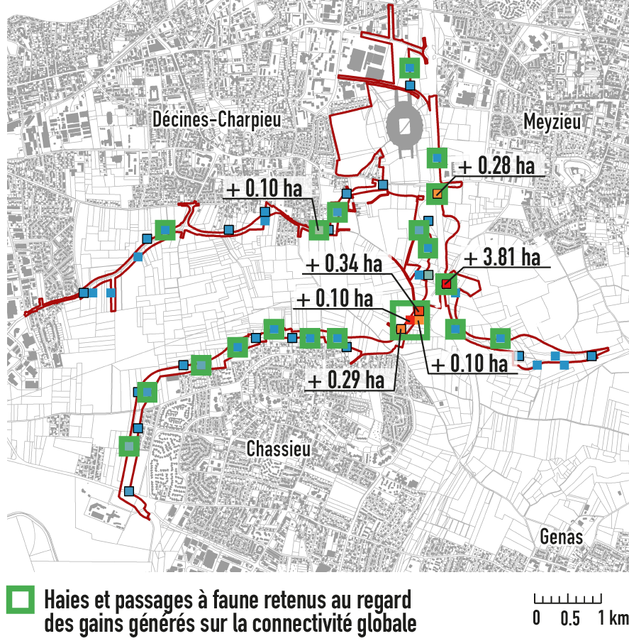

**Assessment of the potential impacts of the Grand Stade in Décines-Charpieu (69) on the ecological networks of the European Badger and preferential locations for mitigation measures.** Taken from Tarabon *et al*. (2019).

# Part 3.

# How to use MitiConnect in mitigation hierarchy

## 3.1 General philosophy

The tool is designed according to a matrix logic integrating the various data processing steps and the stages of the ERC sequence. Although the tool is intended to be flexible, the primary objective is to ensure the logical sequence required to demonstrate the approach, appropriate to all project scales (operations and planning).

In particular, it enables the comparison of different scenarios and the selection of suitable solutions in terms of ecological continuity, at each of the key stages, taking into account the solutions adopted at previous stages. The following figure clearly illustrates the tool's cyclical operation. The evaluation approach it enables can thus contribute to :

* Model the initial state of ecological continuity in the study area,
* Assess the impact of projects on ecological networks in the absence of specific measures,
* Select the geographic variant with the least impact (in cases where several location scenarios are envisaged, as in the case of transport infrastructure corridors) and dimension *in situ* avoidance and reduction measures,
* Search for the most suitable location for compensatory sites, if necessary.

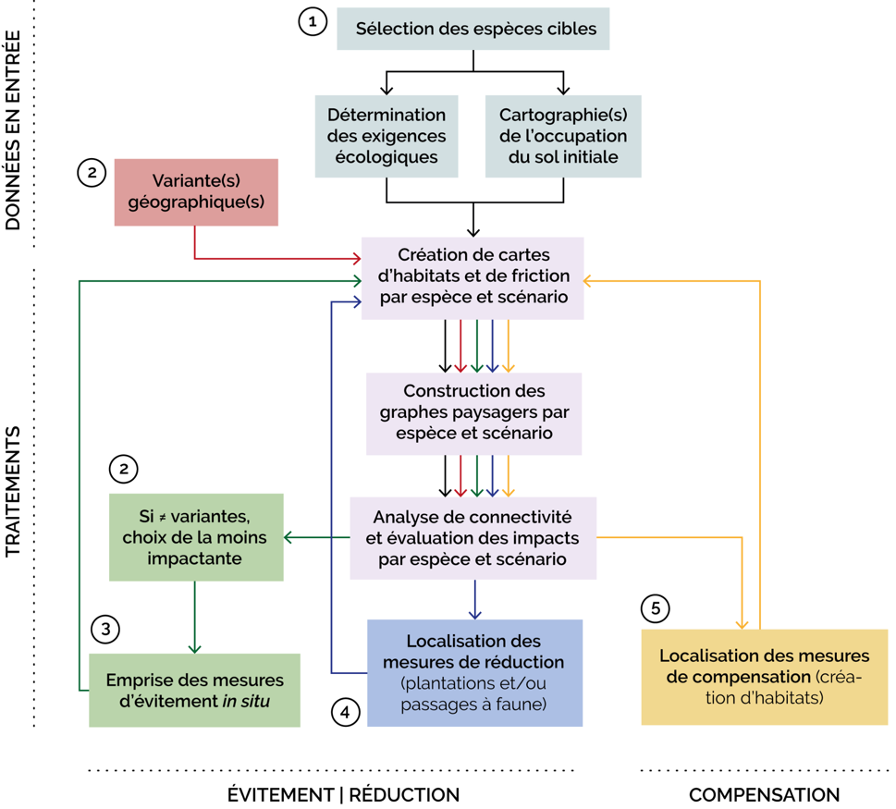

**General operation of the tool represented by a simplified flow chart. The numbers represent the stages in the process.**

The tool defines essential preliminary steps and a multi-phase processing procedure. They concern :

* Selection of target species according to study objectives,
* The preparation of a land cover map, the spatial resolution of which depends on the data available to build it, the species mobilized and the objectives targeted (Thierry *et al.,* 2020),
* Parameterization of models based on available knowledge of target species (scientific literature, expert opinion, field data), determining their dispersal capacity and habitat preferences (environments where species live and those through which they move more or less easily),
* Comparison of different scenarios according to the needs and ambitions of the study, based on a global connectivity indicator (*EC*; Equivalent Connectivity, Saura *et al.*, 2011).

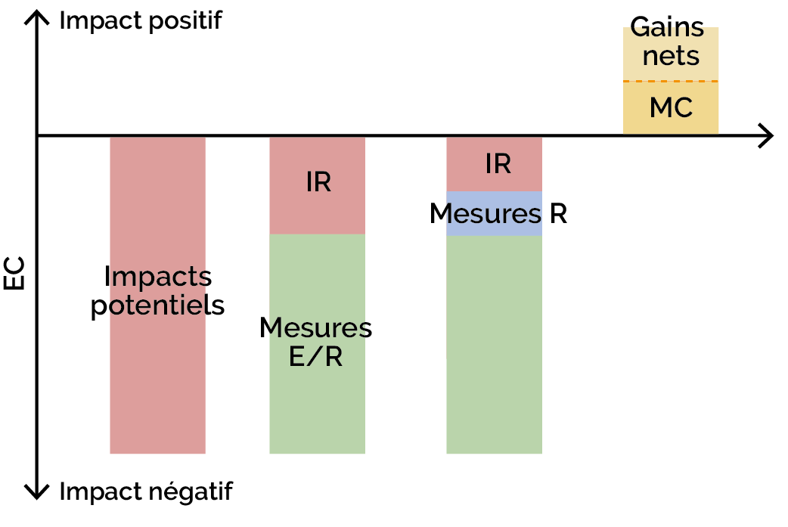

**Ecological equivalence assessment framework applied to ecological continuity**

## 3.2 Application examples

We'd like to illustrate the key stages of numerical simulations enabled by MitiConnect, using an example relating to the motorway project between Machilly and Thonon-les-Bains (Haute-Savoie, 74). It enables us to address the question of geographical variants (or more localized avoidance measures), to test a range of mitigation measures (here in the form of wildlife crossings) and to assess the benefits of *ex situ* compensatory sites.

This global evaluation logic applies to all types of project and all scales.

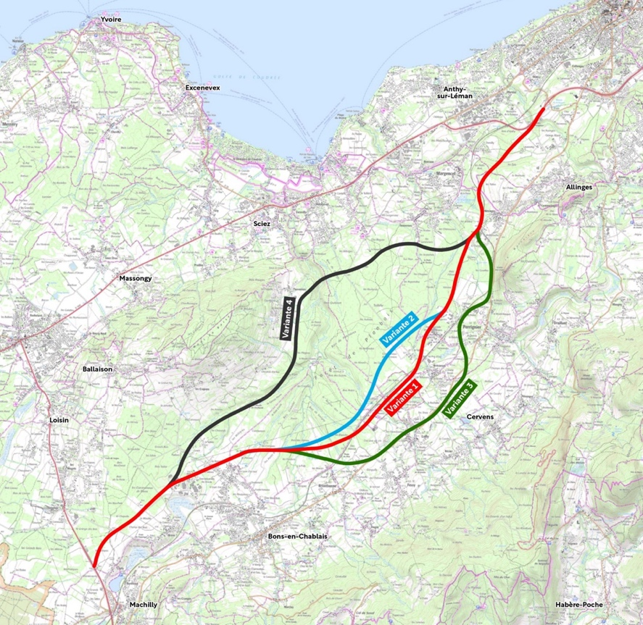Motorway project variants between Machilly and Thonon-les-Bains (74)

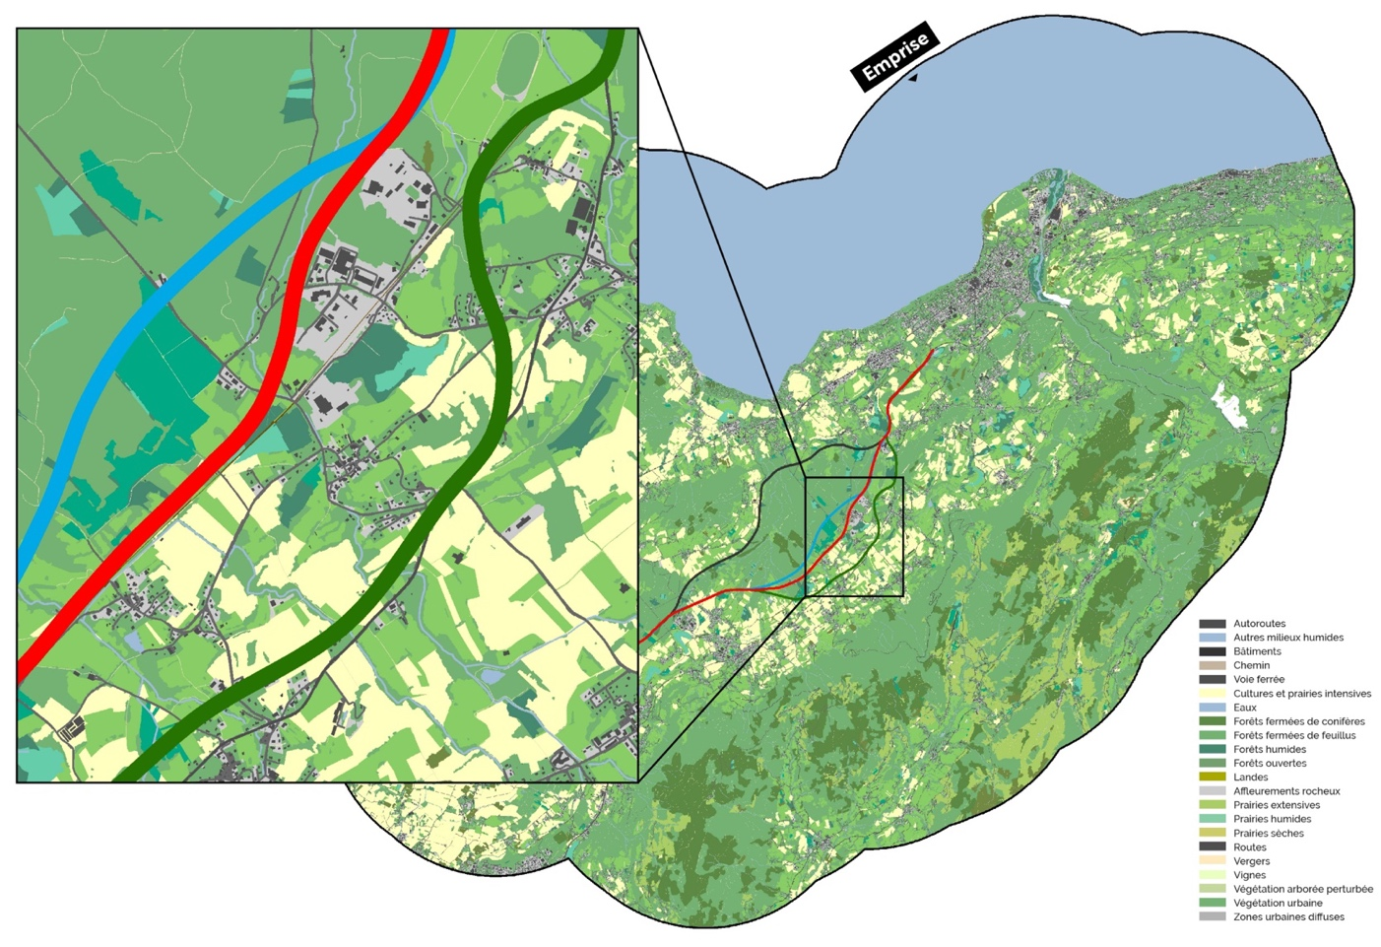

Land use map compiled prior to digital processing

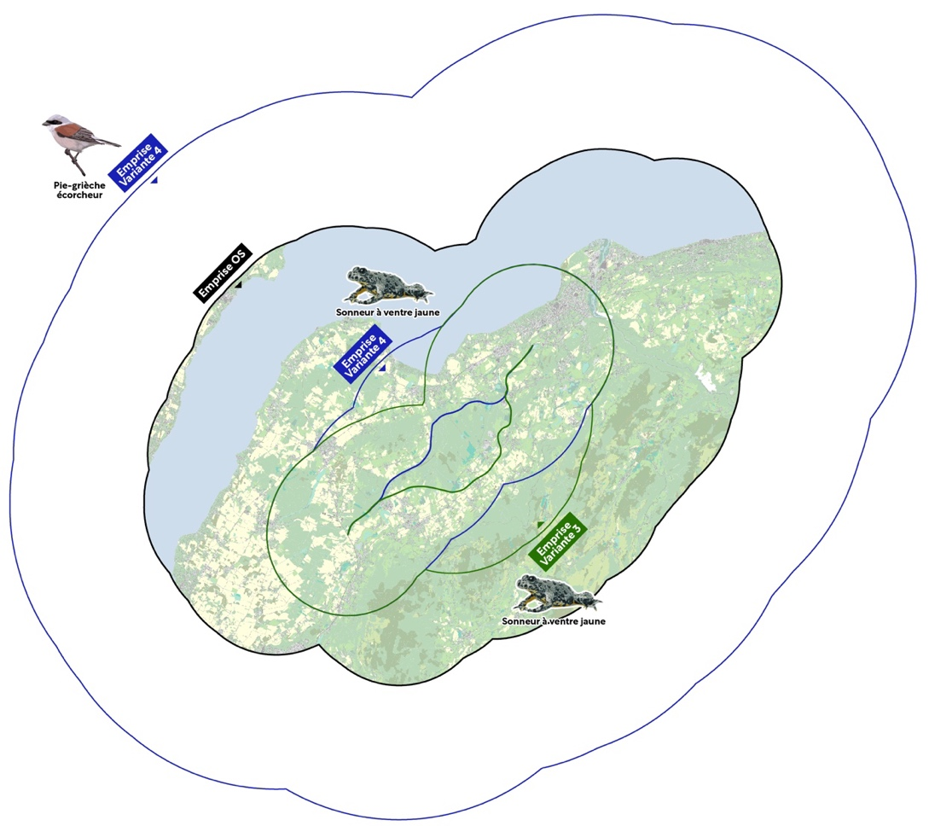

Location of defined rights-of-way by target species. The case of the Shrike reminds us that land use must be compiled over a sufficiently large study area to take account of the species' maximum dispersal capacity in the assessment.

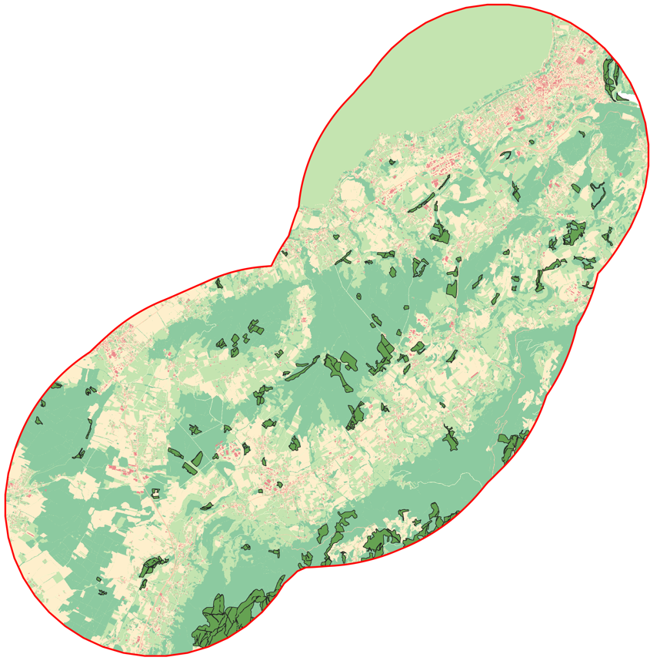

Identifying Yellow-bellied Sounder habitats

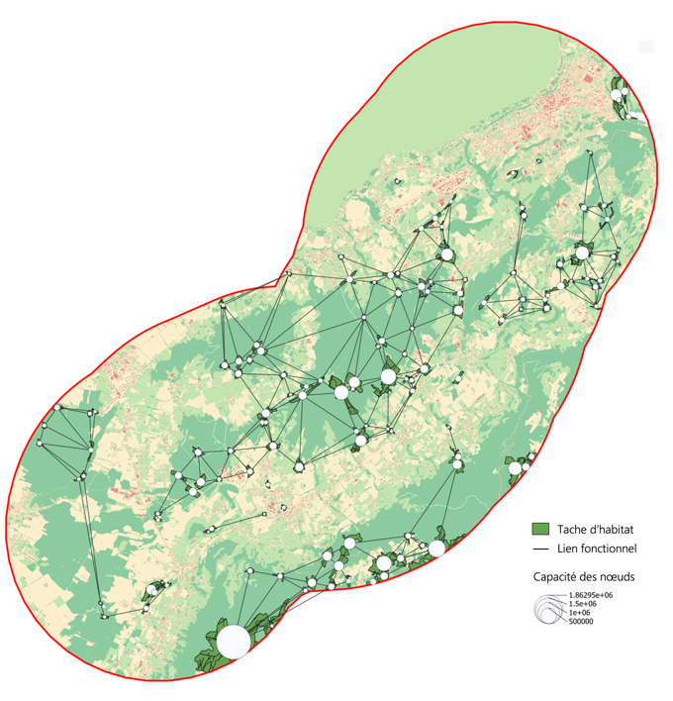 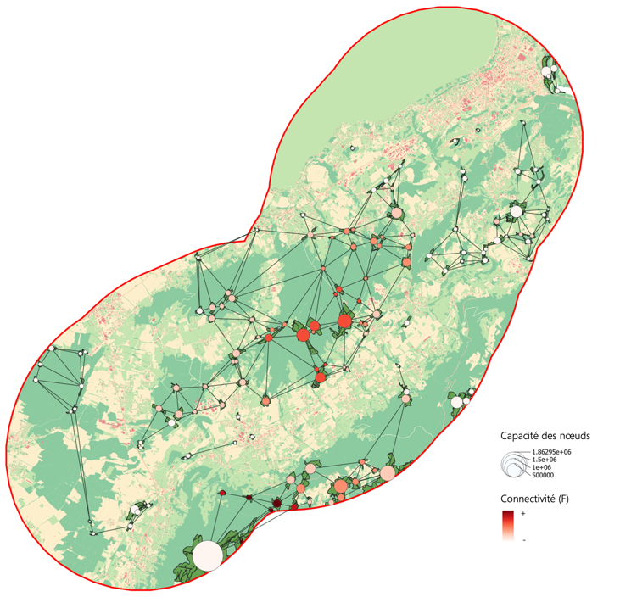

Identification of landscape graphs representing connected nodes for the target species (Yellow-bellied Sounder) and assessment of node importance using a local metric (F)

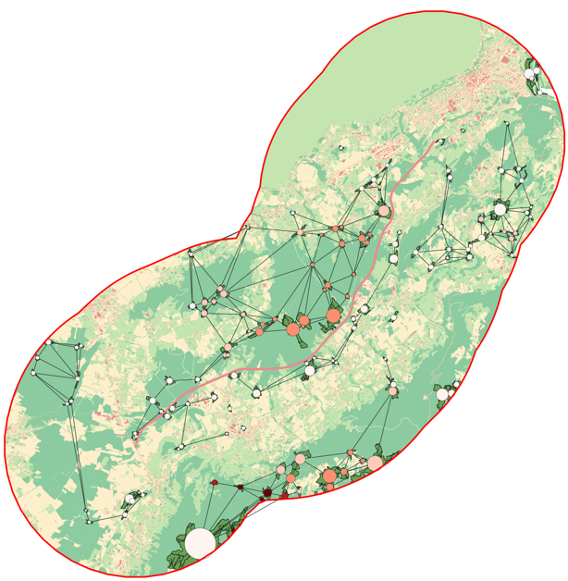 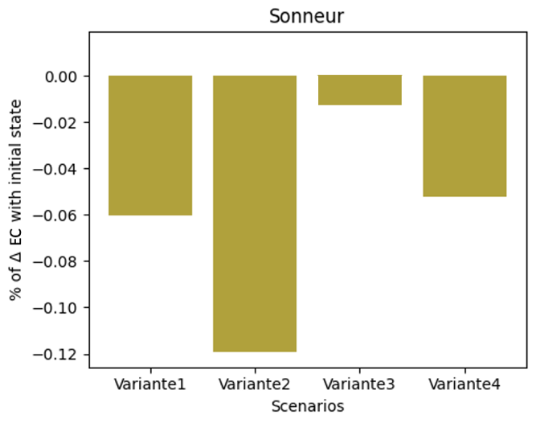

Left: assessment of the potential impact of a variant on the initial ecological continuity. Right: assessment of the impacts of the four variants (scenarios) and identification of the least impacting (Variant no. 3) for the target species, based on the overall *EC* metric. The assessment is reproduced for all the ecological networks tested.

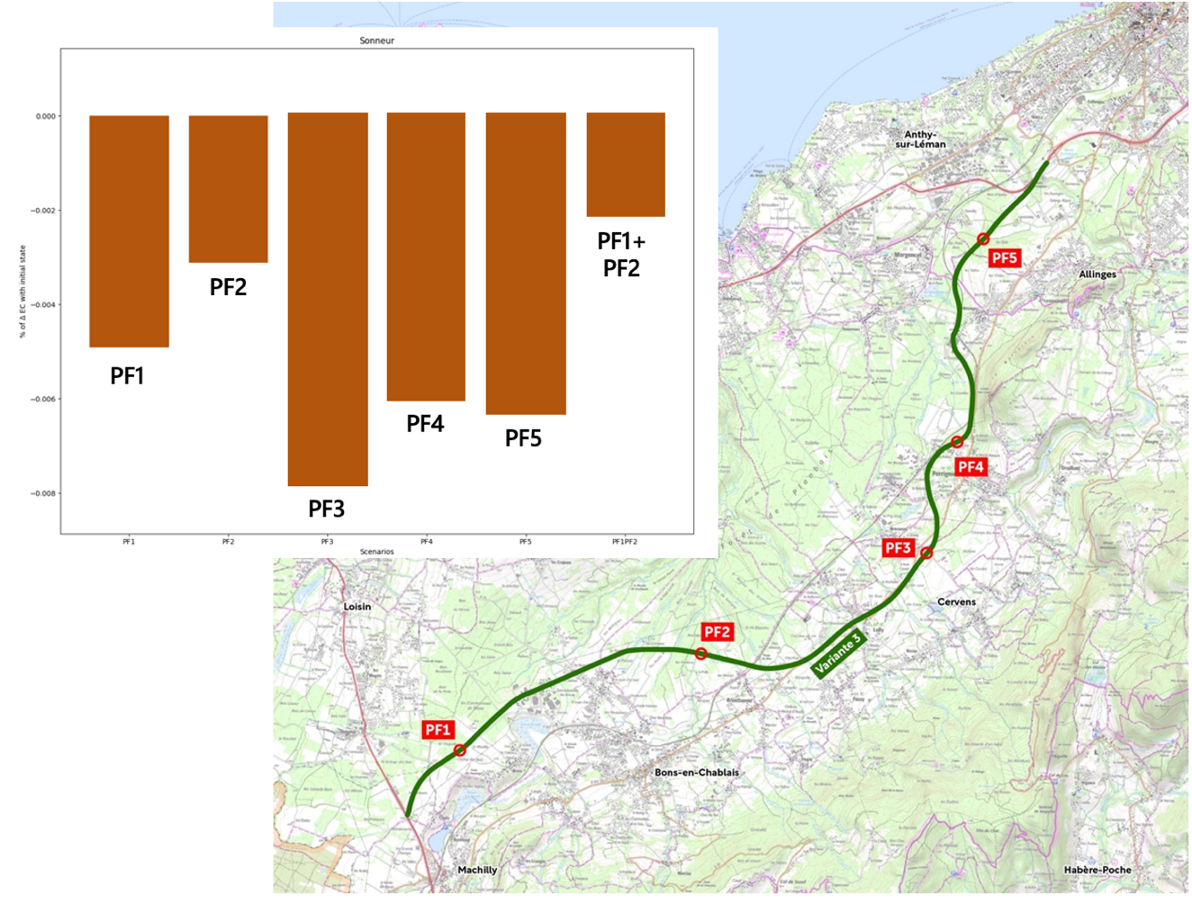

Comparison of residual impacts with the installation of 5 wildlife crossings. Tests can be carried out per FP or by selecting several (assessment of cumulative positive effects).

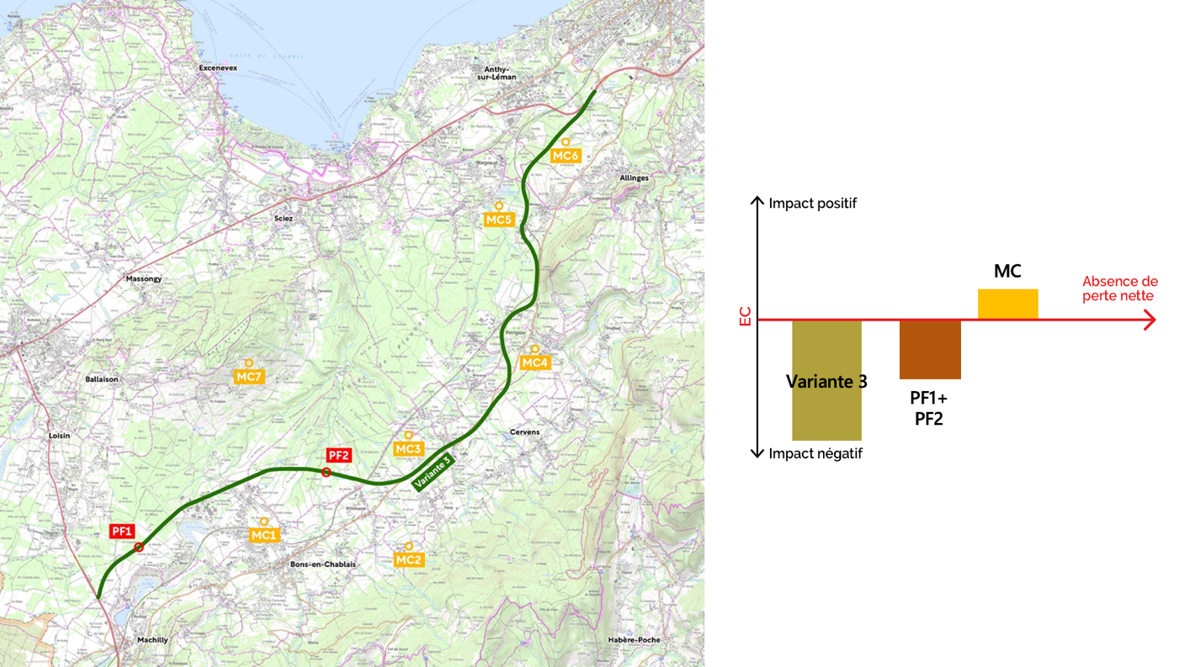

Tests the effects of several compensatory sites (CS) and demonstrates ecological equivalence for the target species following application of the ERC approach. The tool can also be used to illustrate the functional links between habitats and the presence of CMs.

# Part 4.

# MitiConnect User Manual v1 .0



## 4.1. Prerequisites

### 4.1.1. Configuration

MitiConnect runs on any operating system (Linux, Windows, Mac, etc.) with a QGIS version greater than or equal to 3.16 [(](https://www.qgis.org/fr/site/forusers/download.html)https://www.qgis.org/fr/site/forusers/download.html) and a Java version greater than or equal to 8 [(](https://adoptopenjdk.net/)https://adoptopenjdk.net, preferably the 64-bit version).

Tests were carried out under QGIS TODO, Windows 11 and Ubuntu 18.04.1 (bionic). Under Linux, installation of the *python-gdal* package is required. Some features may work without Java.

MitiConnect is freely available under GPL license.

### 4.1.2 Installation

To install the extension from QGIS, go to the '*Extensions'* menu, then '*Install/Manage extensions'*. In the '*All'* tab, search for the '*MitiConnect'* plugin, select it and press *'Install extension'*.

To install the extension in QGIS from the .zip archive, go to the '*Extensions'* menu, then '*Install/Manage extensions',* '*Install from zip*' and select the downloaded '*MitiConnect.zip'* file.

After successful installation, the TODO icon is displayed in the toolbar and a new *MitiConnect* entry is available in the '*Extensions*' menu. If the icon is not displayed, go to the '*Extensions'* menu, uncheck and then recheck the line corresponding to *MitiConnect*.

### 4.1.3. Quote

*Chailloux M., Tarabon S., Papet G., Amsallem J. & Vanpeene S (2024). MitiConnect: a QGIS extension to integrate ecological continuities into the Avoid-Reduce-Compensate (ERC) sequence.*

## 4.2 User manual

The tool's technical guide is detailed in a companion document entitled *MitiConnect v1.0 - User Manual.* It details the entire processing chain, step by step.

# Bibliography

App et al. 2022. Making the case for gardens: Estimating the contribution of urban gardens to habitat provision and connectivity based on hedgehogs (Erinaceus europaeus).

Albert, C. H., & Chaurand, J. (2018). How to select species to identify coherent ecological networks between administrative and biological levels? Sciences Eaux & Territoires, (25), 26-31.

Bergès, L., Avon, C., Bezombes, L., Clauzel, C., Duflot, R., Foltête, J.-C.,... Spiegelberger, T. (2020). Environmental mitigation hierarchy and biodiversity offsets revisited through habitat connectivity modeling. Journal of Environmental Management 256: 109950.

Bergès, L., Avon, C., Bezombes, L., Clauzel, C., Duflot, R., Foltête, J. C., ... & Spiegelberger, T. (2019). Integrating landscape connectivity into the ERC sequence: an approach by the amount of habitat achievable. VertigO: the electronic journal in environmental sciences, 19(2).

Bezombes, L. (2017). Development of a methodological framework for the assessment of ecological equivalence: Application in the context of the "Avoid, Reduce, Compensate" sequence in France (Doctoral dissertation, Thèse de Doctorat, Université Grenoble Alpes, IRSTEA).

Bigard, C. (2018). Avoid-Reduce-Compensate: from a conceptual ideal to implementation challenges: a multidisciplinary and multi-scale analysis (Doctoral dissertation, Université Montpellier).

Bodin, Ö. and Saura, S. (2010). Ranking individual habitat patches as connectivity providers: integrating network analysis and patch removal experiments. Ecological Modelling 221(19): 2393-2405.

Calabrese, J. M. and Fagan, W. F. (2004). A comparison-shopper's guide to connectivity metrics. Frontiers in Ecology and the Environment, 2(10):529-536.

CEREMA, 2017. Analyse de l'intégration des continuités écologiques dans la Séquence Éviter-Réduire-Compenser des projets d'aménagement - Problématiques, pistes et leviers d'amélioration issus de l'analyse de dossiers en Bretagne.

Chailloux, M. & Amsallem, J. (2018). BioDispersal: a QGIS plugin for modeling potential dispersion zones.

Foltête, J. C., Vuidel, G., Savary, P., Clauzel, C., Sahraoui, Y., Girardet, X., & Bourgeois, M. (2021). Graphab: an application for modeling and managing ecological habitat networks. Software Impacts, 8, 100065.

Foltête, J.-C., Clauzel, C. and Vuidel, G. (2012). A software tool dedicated to the modelling of landscape networks. Environmental Modelling & Software 38: 316-327.

Galpern, P., Manseau, M., & Fall, A. (2011). Patch-based graphs of landscape connectivity: a guide to construction, analysis and application for conservation. Biological conservation, 144(1), 44-55.

McRae, B. H., & Kavanagh, D. M. (2011). Linkage mapper connectivity analysis software. The Nature Conservancy, Seattle WA.

McRae, B. H., & Shah, V. B. (2009). Circuitscape user's guide. The University of California, Santa Barbara.

Méchin, A. (2020). Dimensionner les mesures de compensation écologique : des outils opérationnels pour une meilleure appropriation par les acteurs de l'aménagement du territoire (Doctoral dissertation, Université Paul Valéry-Montpellier III).

Meurant, M., Gonzalez, A., Doxa, A. & Albert, C.H. 2018. Selecting surrogate species for connectivity conservation. Biological Conservation 227: 326-334

Moulherat, S., Bestion, E., Baguette, M., Moulherat, M., Palmer, S. C., Travis, J. M., & Clobert, J. (2020). MetaConnect, a new platform for population viability modelling to assist decision makers in conservation and urban planning. bioRxiv, 2019-12.

Moulherat, S., Remon, J., Baguette, M., & Le Gallic, Y. (2017). CIRFE-Cumulative linear terrestrial transport infrastructures and Ecological Functional Relationships.

Moulherat, S. (2014). Toward the development of predictive systems ecology modeling: MetaConnect and its use as an innovative modeling platform in theoretical and applied fields of ecological research (Doctoral dissertation, University of Toulouse, University Toulouse III-Paul Sabatier).

MTES, 2019. Propositions pour l'amélioration de la qualité des évaluations environnementales, Report No. 012747-01. <https://www.vie-publique.fr/sites/default/files/rapport/pdf/273874.pdf>

Newbold, T., L. N. Hudson, A. P. Arnell, S. Contu, A. De Palma, ... and A. Purvis, 2016, Has land use pushed terrestrial biodiversity beyond the planetary boundary? A global assessment, Science, 353, 6296, pp. 288-291.

Ollivier, C., Spiegelberger, T., & Gaucherand, S. (2020). La territorialisation de la séquence ERC: quels enjeux liés au changement d'échelle spatiale? Sciences Eaux Territoires, 31(1), 50-55.

Papet, G & Vanpeene S., Graphes paysagers et séquence ERC. How to integrate ecological continuities into the ERC sequence using landscape graph tools? June 2020. 22p.

Saura, S., & Torne, J. (2009). Conefor Sensinode 2.2: a software package for quantifying the importance of habitat patches for landscape connectivity. Environmental modelling & software, 24(1), 135-139.

Sahraoui, Y., Foltête, J.C, and Clauzel, C. 2017. A multi-species approach for assessing the impact of land-cover changes on landscape connectivity. Landscape Ecology, 32(9) 1819-1835.

Foltête, J.C, Girardet, X. and Clauzel, C., 2014. A methodological framework for the use of landscape graphs in land-use planning. Landscape and Urban Planning, 124 140-150.

Rudnick, D., Ryan, S.J., Beier, P., Cushman, S.A., Dieffenbach, F., Epps, C.,... Kintsch, J. (2012). The role of landscape connectivity in planning and implementing conservation and restoration priorities. Issues in Ecology.

Saura, S., Estreguil, C., Mouton, C., and Rodríguez-Freire, M., 2011. Network analysis to assess landscape connectivity trends: Application to european forests (1990-2000). Ecological Indicators, 11(2) 407- 416.

Savary, P. (2021). Joint use of genetic and landscape graphs for habitat ecological connectivity analysis.

Tarabon S. Intégration des fonctionnalités écologiques dans le cadre de l'aménagement des territoires et de la séquence Éviter-Réduire-Compenser, de l'échelle projet à la planification. Biodiversity and Ecology. Avignon University. 2020. PhD thesis

UN, 2018. The 2017 Revision of World Population Prospects. Retrieved November 9, 2019, from https://population.un.org/wpp/, United Nations. Urban, D., Keitt, T., 2001, Landscape connectivity: a graph-theoretic perspective, Ecology, vol. 82, no. 5, pp. 1205-1218, https://doi.org/10.2307/2679983

Urban, D. L., Minor, E. S., Treml, E. A., & Schick, R. S. (2009). Graph models of habitat mosaics. Ecology letters, 12(3), 260-273.

Urban, D. and Keitt, T. (2001). Landscape connectivity: a graph-theoretic perspective. Ecology 82(5): 1205-1218

van Etten, J. (2017). R package gdistance: distances and routes on geographical grids. Journal of Statistical Software, 76(1), 1-21.

Vogt, P., Riitters, K. H., Iwanowski, M., Estreguil, C., Kozak, J. and Soille, P. (2007). Mapping landscape corridors. Ecological Indicators, 7(2):481-488.

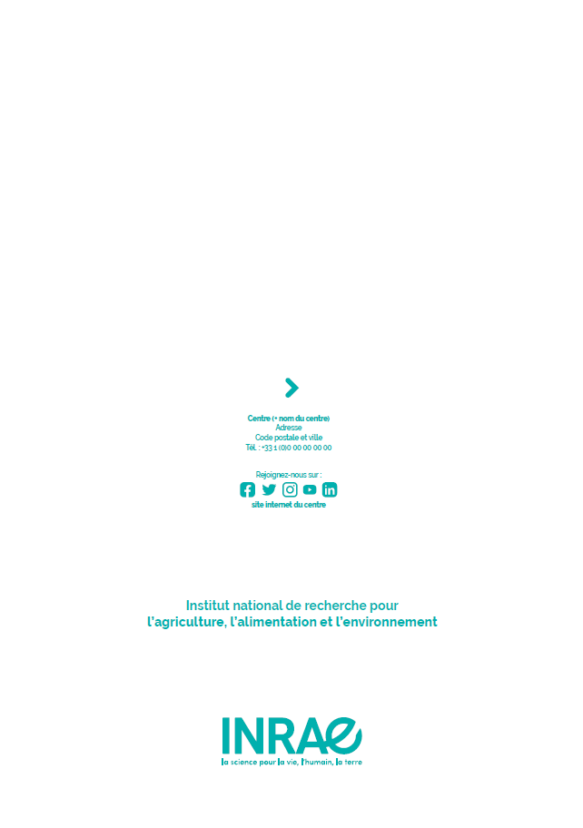

**Center Provence-Alpes-Côte d'azur**

3275 route Cézanne CS 40061

13182 Aix-en-Provence

Phone: +33 (0)4 42 66 99 10

1. See, for example, the CONAQUAT project, which aims to study the contribution of three innovative approaches (environmental DNA, landscape genetics and digital simulation) to the application of mitigation hierarchy for biodiversity in aquatic environments.
2. Including SRCE for Île de France, PADDUC for Corsica and SAR in the French overseas territories.
3. ITTECOP (Infrastructures de Transports Terrestres, ÉCOsystèmes et Paysages) is an incentive research program led by the French Ministry of Ecological Transition and Territorial Cohesion (MTECT), in coordination with the French Environment and Energy Management Agency (ADEME) and with the support of CILB, whose main objective is to compare the technical challenges of transport infrastructures and their interfaces with territories, including landscape and ecosystem dimensions - www.ittecop.fr
4. The Agence nationale de la recherche (ANR) is a public establishment under the authority of the French Ministry of Higher Education, Research and Innovation, which provides project-based research funding for public operators in cooperation with each other or with companies.
5. In France, for example, the housing and agricultural building sectors are rarely subject to impact assessment, yet they account for 50% of the consumption of natural, agricultural and forestry areas. https://www.actu-environnement.com/ae/news/zero-artificialisation-sols-gestion-collectivites-promoteurs-  
   immobiliers-35200.php4#xtor=ES-6
6.